**IOOIOO peripage printer video, FAQ, trouble shooting, quick start, user manual V231028**

Customer service email: [iooioo@qq.com](mailto:iooioo@qq.com), whatsapp: 008614775058163

|  |  |
| --- | --- |
| Quick Start Video (Video also available at product page): | |
| How to connect with phone? | <https://youtu.be/dwxlKg2wvLA> |
| How to connect Windows PC with USB cable? | <https://youtu.be/G--Wj7Tbe8g> |
| How to connect Mac PC with USB cable? | <https://youtu.be/C_Wut0QmEEA> |
| How to install letter rolled paper? | <https://youtu.be/n2WEGj-94bo> |
| How to install letter folded paper? | <https://youtu.be/CV_Q1Dc1j-M> |
| How to make the rolled curled paper flat? | <https://youtu.be/DNs9e4jS00k> |

**FAQ and trouble shooting:**

|  |  |  |
| --- | --- | --- |
| **Problem** | **Root Cause** | **Solution** |
| Bluetooth could not connect with phone or Windows PC (Every unit was double tested by seller before shipment) | Connect it in the wrong way. | Follow the video on our product page to connect it by Bluetooth or USB. |
| The phone is in lower battery power saving mode. | Charge the phone. |
| Try to connect the printer in the phone Bluetooth list, which is a wrong way to connect the printer with Bluetooth. | Do not try to connect it at the phone Bluetooth list, please connect it within the Peripage APP, after activating the Bluetooth of the phone. Please refer to the step-by-step guideline in this document chapter 3.1 on how to connect the Android, iPhone with Bluetooth. |
| The phone is not compatible, such as the phone is too old. | Change a newer phone to test and confirm if the phone causing the problem. |
| The printer is connecting with the 1st phone. The 2nd phone could not connect. | 1. Disconnect with the 1st phone, and connect the 2nd phone again.   Charge the phone. |
| How to make the curled paper flat? | The paper was printed from the rolled paper | 1. Slide at the edge of the desk to make it flat, the sharper the edge, the better it will be:      1. Buy the folded paper, but not rolled paper. |
| The rolled letter size paper could not be installed. | The two holders are not removed | Remove the two holders which stop the rolled letter paper. |
| Why print nothing? | The paper is upside down. Only one side is printable. | Please print with another side. |
| The print quality is not clear | The font in your document is not supported by your OS system. | Choose the font supported by your OS system, such as Ariel or Ariel Black, and so on. |
| Density/Concentration/Darkness is not set to max 5, but 2. | Set density/Concentration/ Darkness to 5 |
| The line in the font is too small | Change to other fonts with thick line |
| The text font size is too small | Enlarge the font size |
| The picture is too small | Enlarge the picture in the paper |
| Picture and text are mixed | Use phone image printing: |
| The thermal paper quality is not good | Use the good quality general thermal paper or use the IOOIOO thermal paper which is available at our store |
| The DPI (Dots Per Inch) is just 203DPI, but not 300DPI | Buy our high DPI resolution version of print A40 Pro with 300DPI |
| Why print at the broken line of the folded paper when printing about 10 pages continuously? | The folded paper without the black mark for printer to recognize it is not well compatible with the printer. | 1. If you are using other not compatible paper, please set the parameter to be 11(Or the actual shifting of each page) as the following:      1. Or buy the peripage compatible folded paper at our store or at amazon. |
| Why some tattoo transfer paper was stuck or the tattoo paper are melted? | The lines in the drawing are with too thin. | Print thick lines in the drawing. |
| The tattoo paper was too bright to mislead the sensor to stop the printing. | Block the sensor with label:  TATTOOstucked |
| The newer version V1.4.3_SD upgrade the printing quality, it does not support tattoo printing any more. | Double click the power button to print the version. |
| The transfer paper was melted, because the printer head temperature is too high to the transfer paper. | 1. Adjust the darkness of the printing from 5 to 0. 2. Print the transfer paper upside down. |
| What’s the meaning of the LED status | Green light on: | Normal use status/fully charged |
| Red light on: | Cover open/No paper/Over-heat/Charging |
| Green light flashing: | Folded paper mode, please insert paper |
| Red light flashing: | Low battery, please charge |
| How to handle the charging | 5V-2A, recommend to use phone charger to charge it | |
| Recommend to fully charge it before using | |
| Please charge it every 3 months if you did not use it for long time to avoid the battery not being able to be charged. | |
| How to clean printer head | Step1: Turn off printer, and open the cover, and take out the paper | |
| Step2: Dip a cotton cloth or cotton swab with medical alcohol, and wipe gently along the center to the periphery of the printer head | |
| Step3: After cleaning the printer head, do not use it immediately. Please wait for 1 to 2 minutes, use the printer after the alcohol has completely evaporated. | |

**Step-by-step Quick Start Guide:**

1.How to install newest Windows PC driver? 3

2.How to install newest Mac PC driver? 11

3.How to install APP in iPhone and android? How to print email in iPhone and android? 25

3.1 How to install APP and connect the printer in iPhone and android phone by Blueooth? 25

3.2 How to print email in iPhone? 25

3.3 How to print gmail in android phone? 25

4.How to print 4”x 6” shipping label in Windows? 26

5. How to print 4”x6” shipping label in Mac PC? 31

6. How to connect Windows PC with printer by Bluetooth? 35

1.How to install newest Windows PC driver?

Step1: Double click the power key to print the hardware version (When the paper is installed and the power key is green), according to the hardware version to click the following link to download the newest driver:

|  |  |
| --- | --- |
| For hardware older than V1.4.3_SD： | For hardware equal or newer than V1.4.3_SD： |
|  |  |
| <https://www.ileadtek.com/resource/drive/cn/%E7%88%B1%E7%AB%8B%E7%86%8APeriPage_A4_203dpi_PC%E9%A9%B1%E5%8A%A8%E5%AE%89%E8%A3%85%E5%8C%85.zip> | <https://www.ileadtek.com/resource/drive/en/PeriPage_A40_PC_driver_installation_Windows_3.0.1.435.zip> |
|  |  |

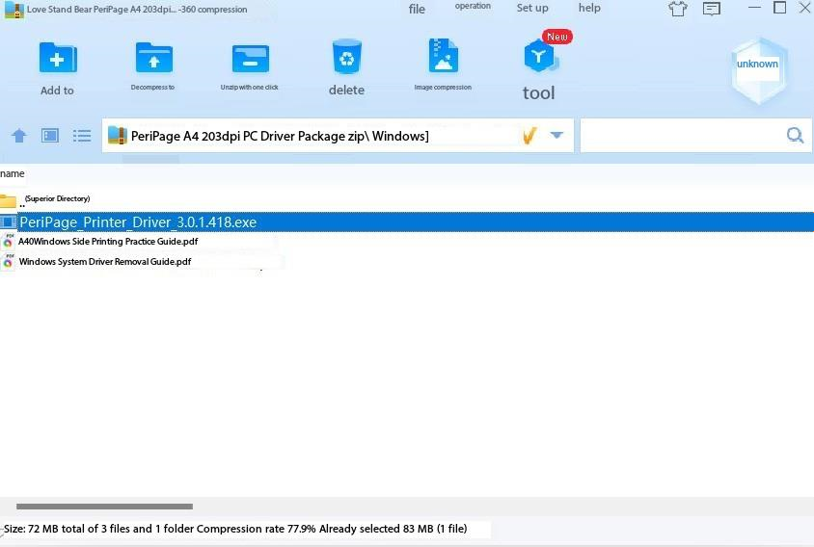

Step2: Click the global icon to change the language into English. And then click Next.

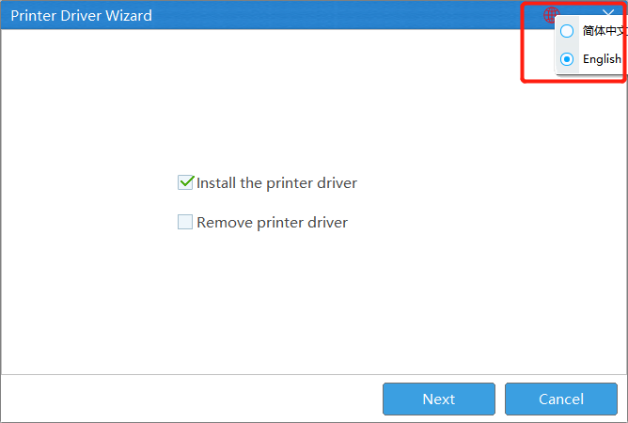

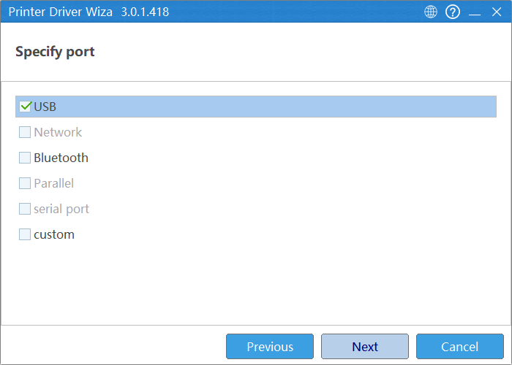

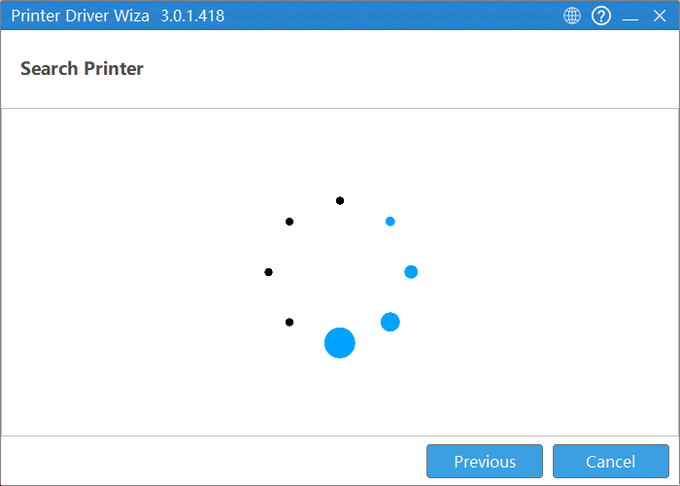

Step3: Long press the power button of the printer for 2 seconds, until the green light is on.

Then plug in the USB cable.

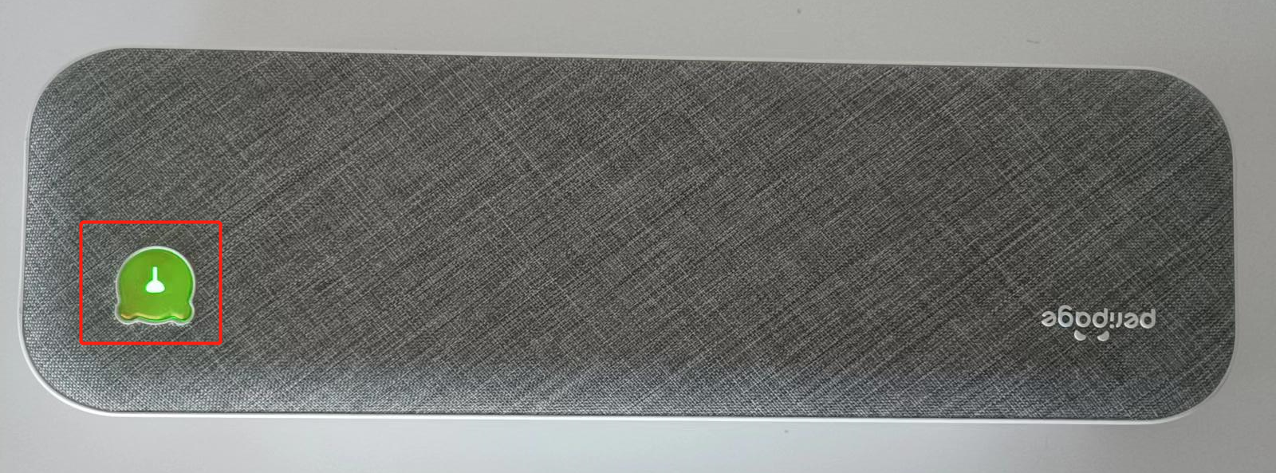

The following page will show up, then click next continuously.

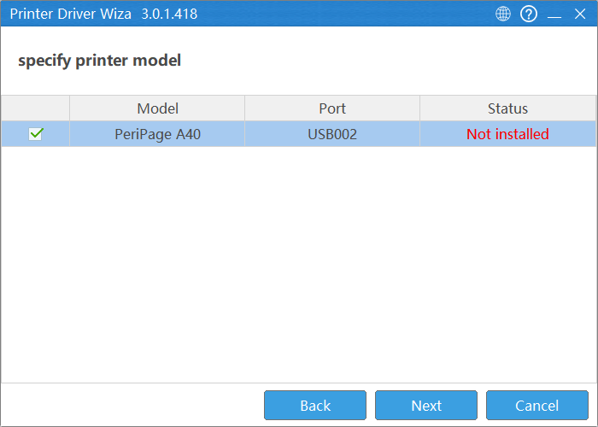

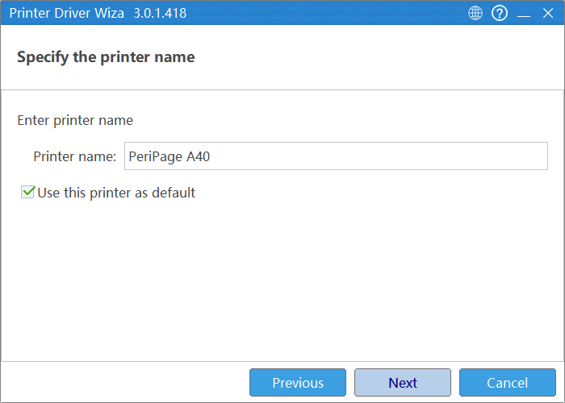

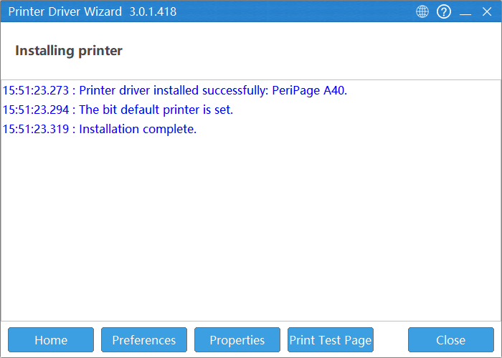

Step4: If the printer do not show up on the searching printer page, please make sure that: before plugging in the USB cable, the green light of the printer is still on. And make sure the “print spooler” service is running on your PC.

If you need to activate the “print spooler” service for your PC. Please select Windows logo key + R to open Run. Then type "services.msc", and select OK.

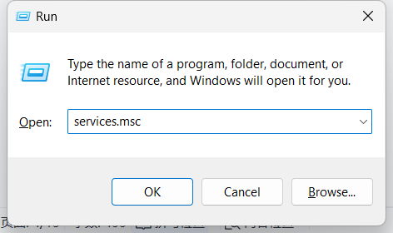

Then Right-click “Print Spooler”. Then select Start.

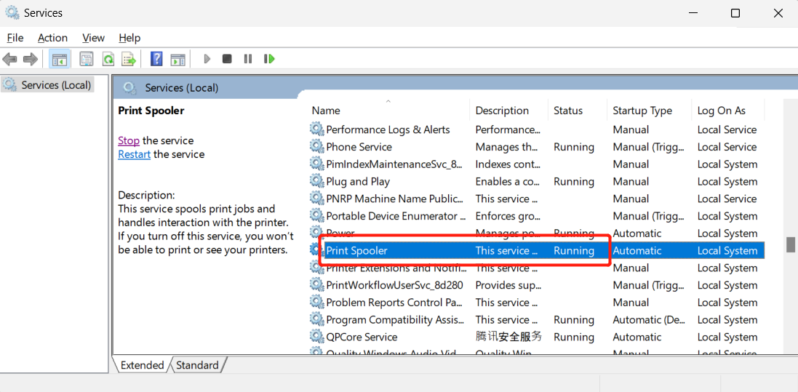

Step5: Open the file to be printed, such as a TXT file. And select “PeripageA40” and then click “More settings”.

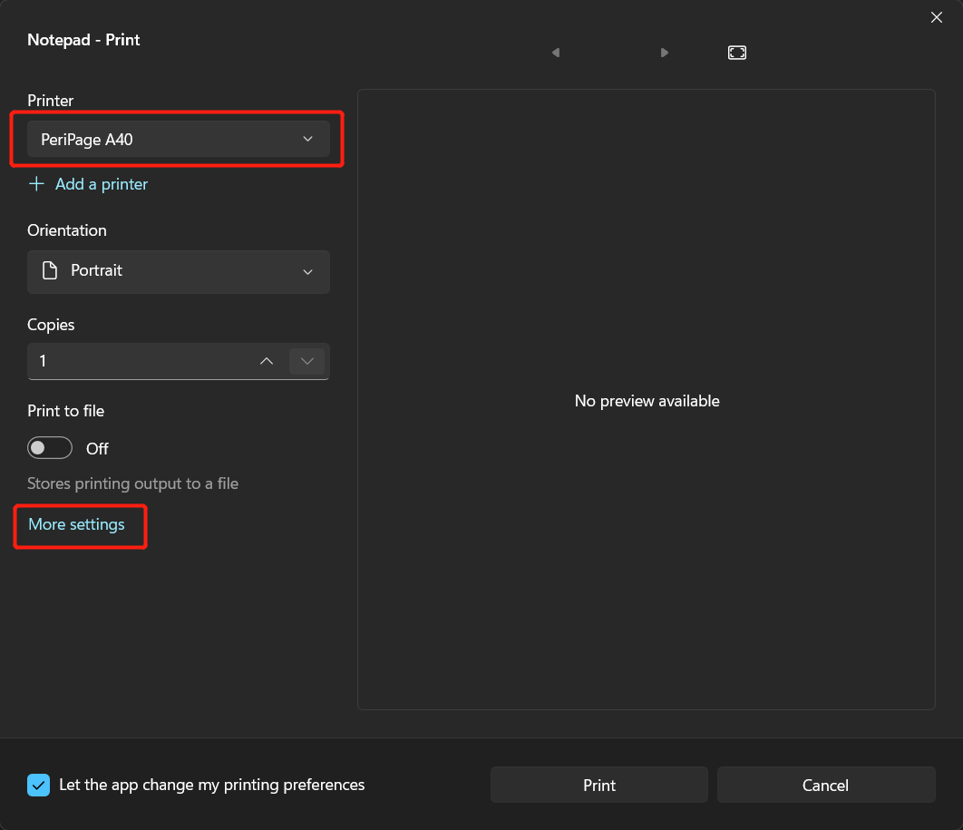

Step6: Then select actual paper size, such as “A4[204*291]”. And then select the “Density” to be 5.

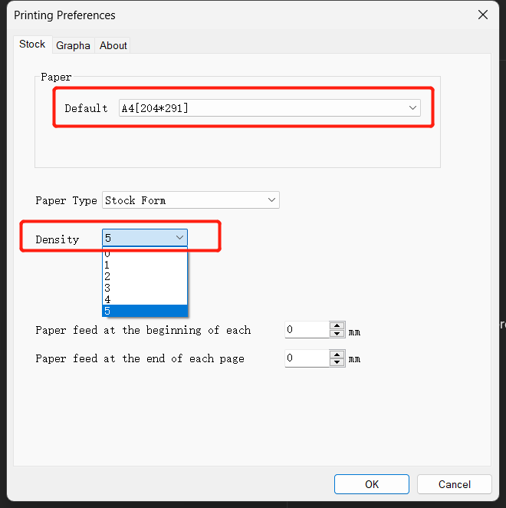

Step8: Click OK button to print:

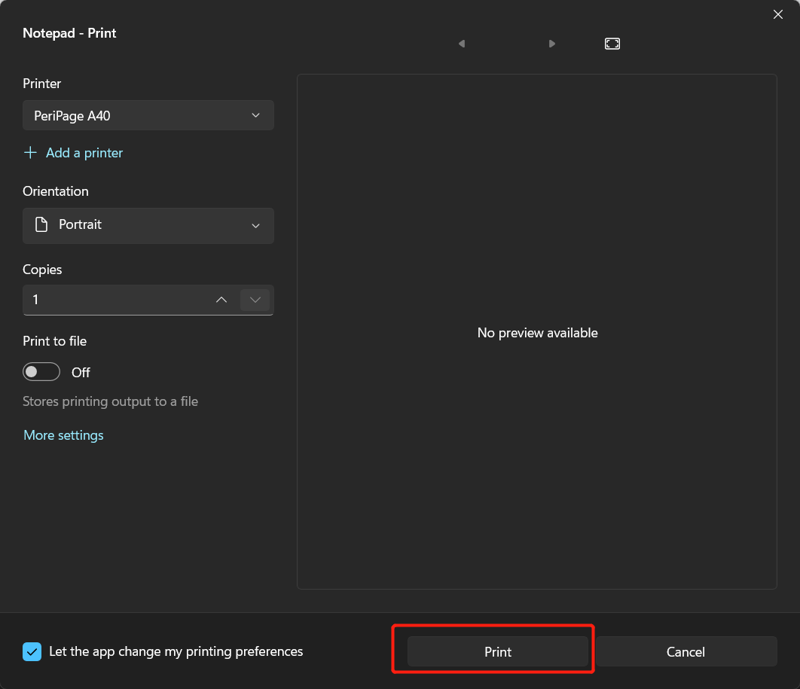

2.How to install newest Mac PC driver?

Step1: Double click the power key to print the hardware version (When the paper is installed and the power key is green), according to the hardware version to click the following link to download the newest driver:

|  |  |
| --- | --- |
| For hardware older than V1.4.3_SD： | For hardware equal or newer than V1.4.3_SD： |
|  |  |
| <https://www.ileadtek.com/resource/drive/cn/%E7%88%B1%E7%AB%8B%E7%86%8APeriPage_A4_203dpi_Mac%E6%89%93%E5%8D%B0%E9%A9%B1%E5%8A%A8%E5%AE%89%E8%A3%85%E5%8C%85.zip> | <https://www.ileadtek.com/resource/drive/en/PeriPage_A40_PC_driver_installation_Mac_3.0.1.434.zip> |

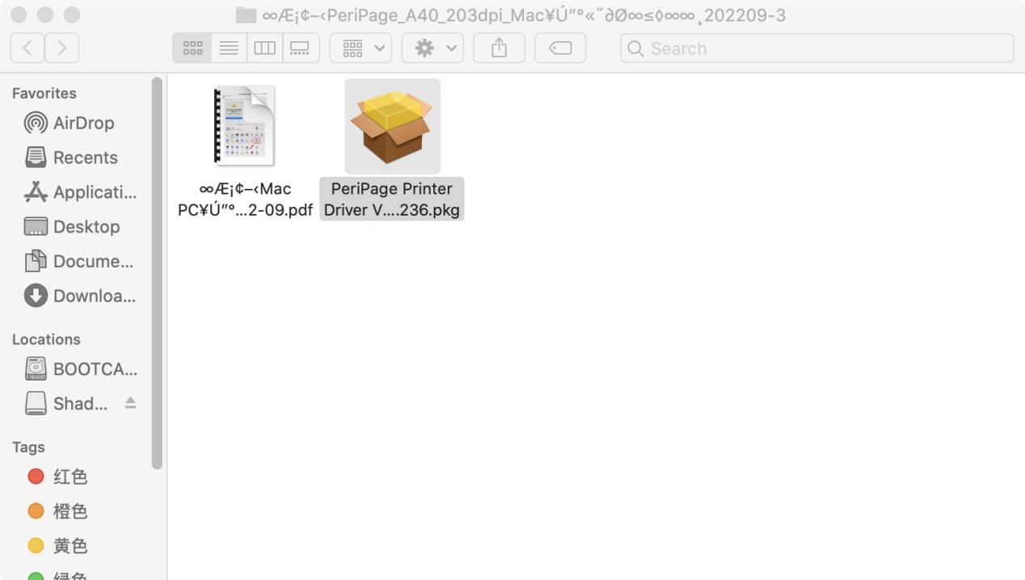

Step2: Click and run the .pkg file.

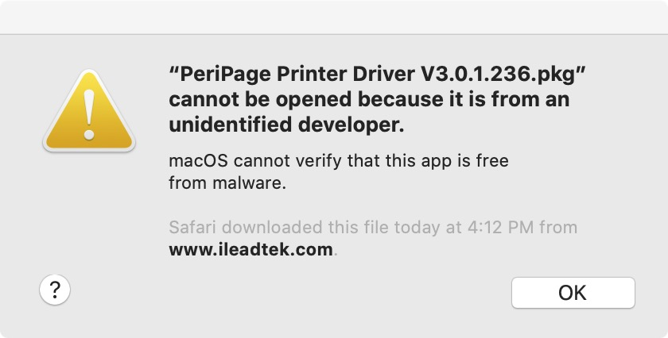

Step3: Go to System Preference->Security&Privacy, then click the following red rectangle sequentially.

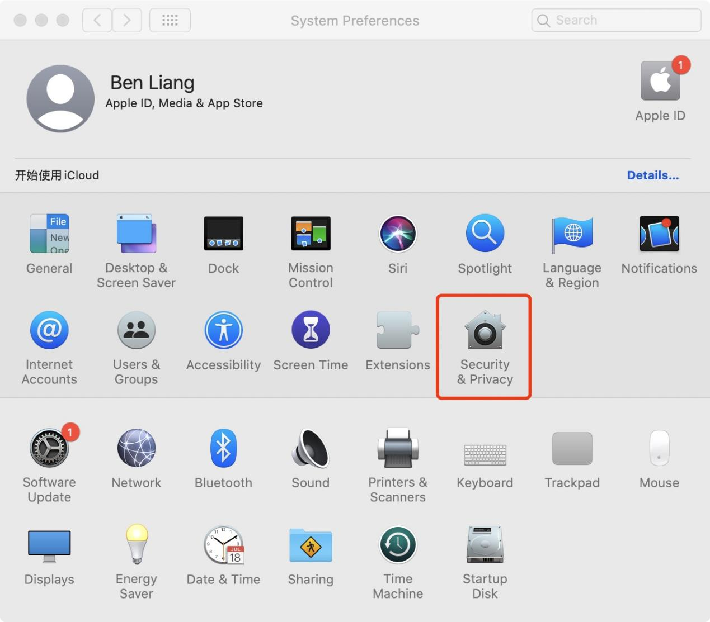

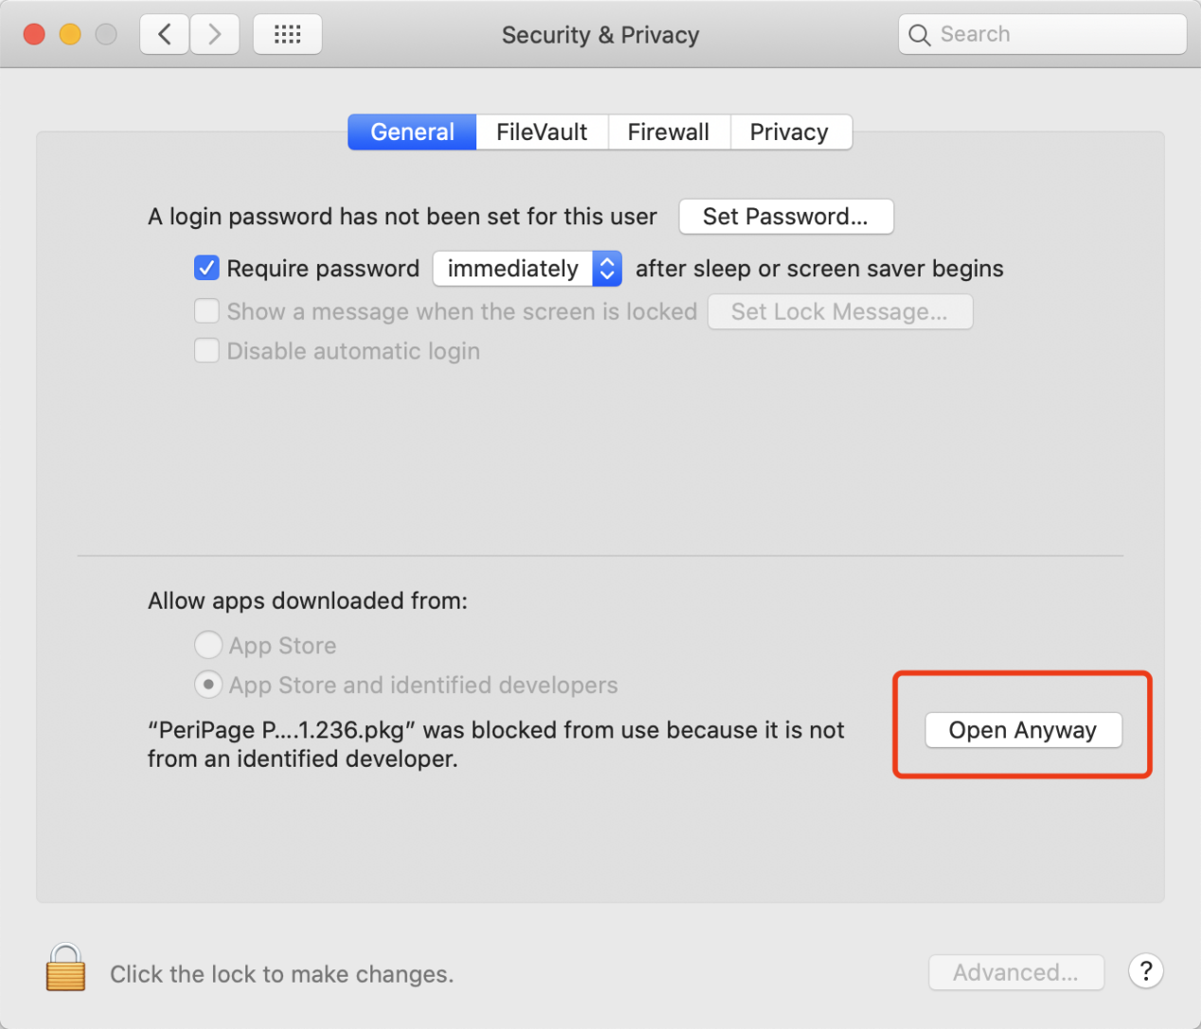

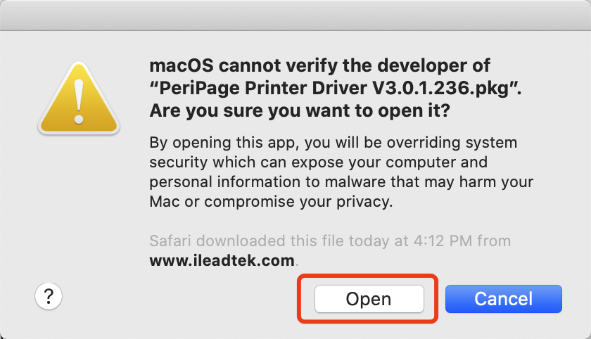

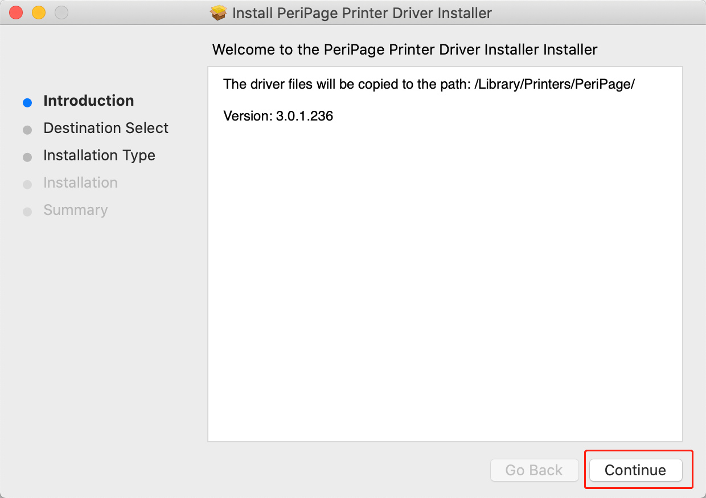

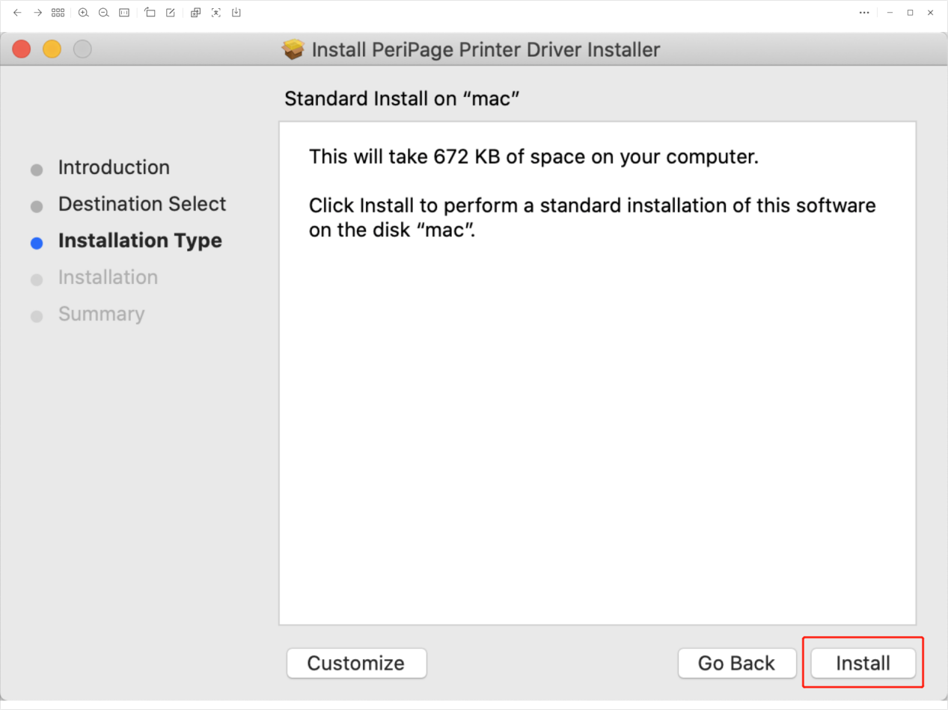

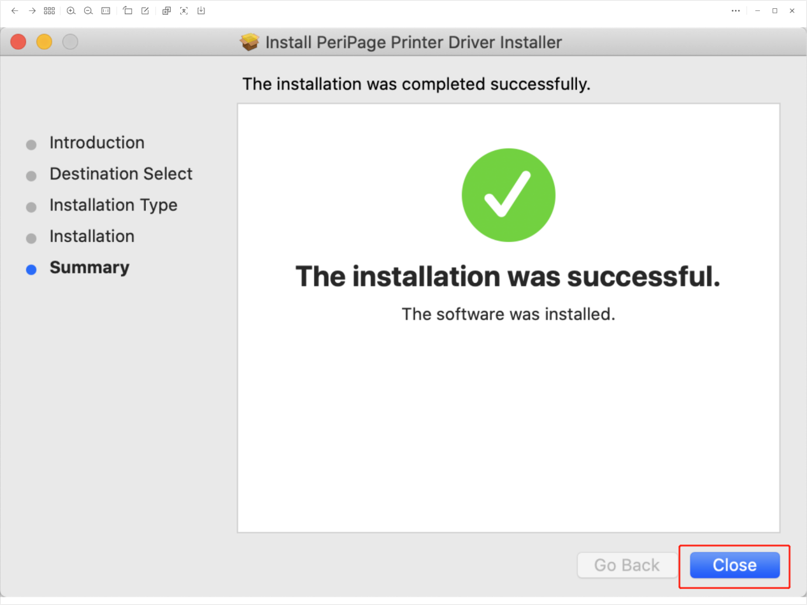

Step4: Go to System Preference->Printers&Scanners, then click the following red rectangle sequentially.

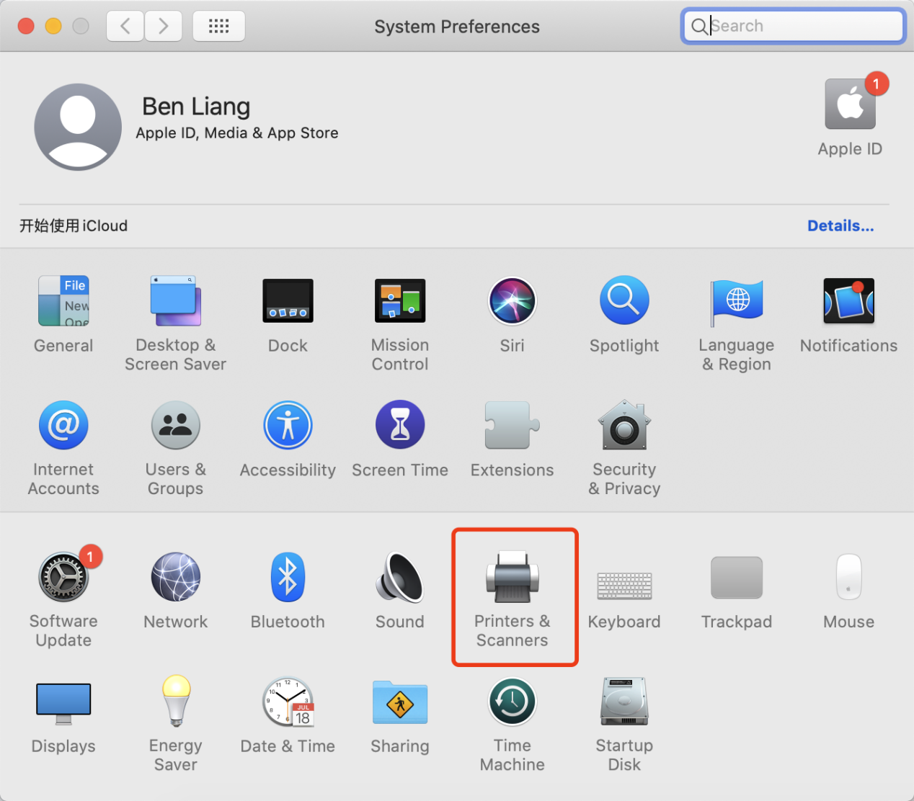

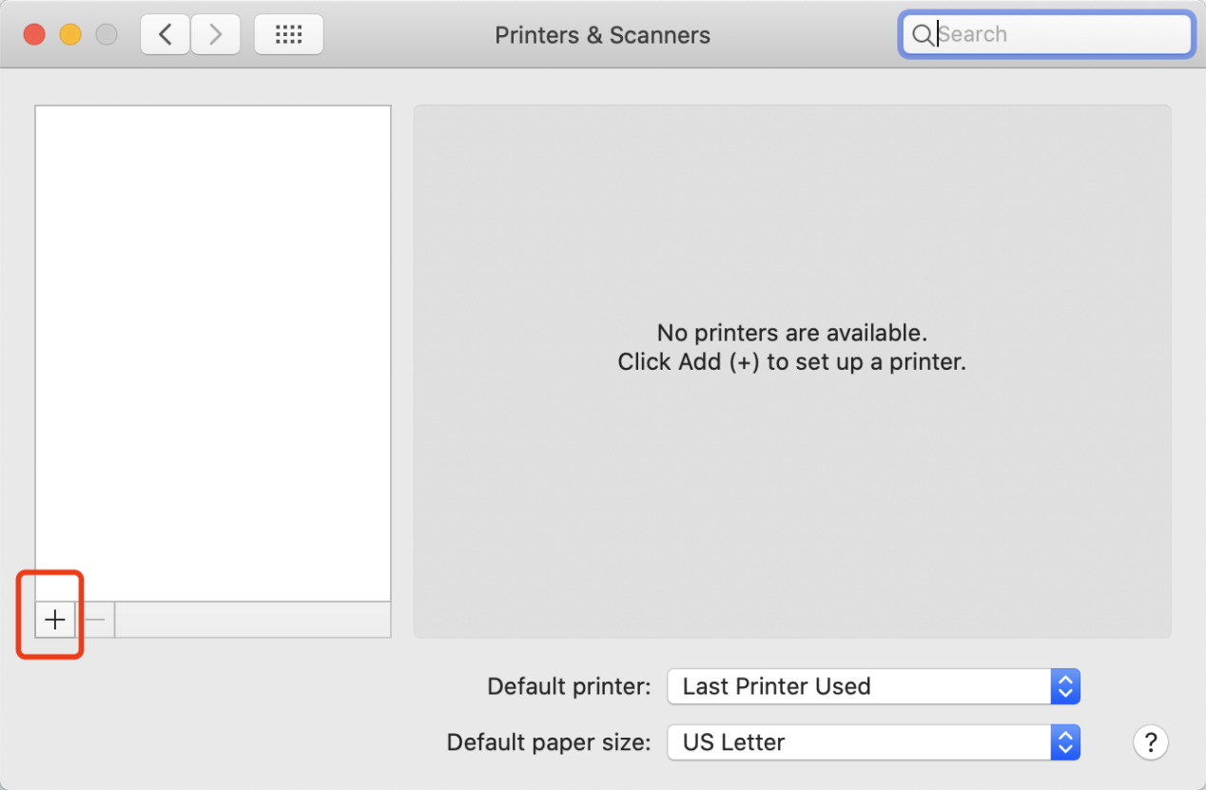

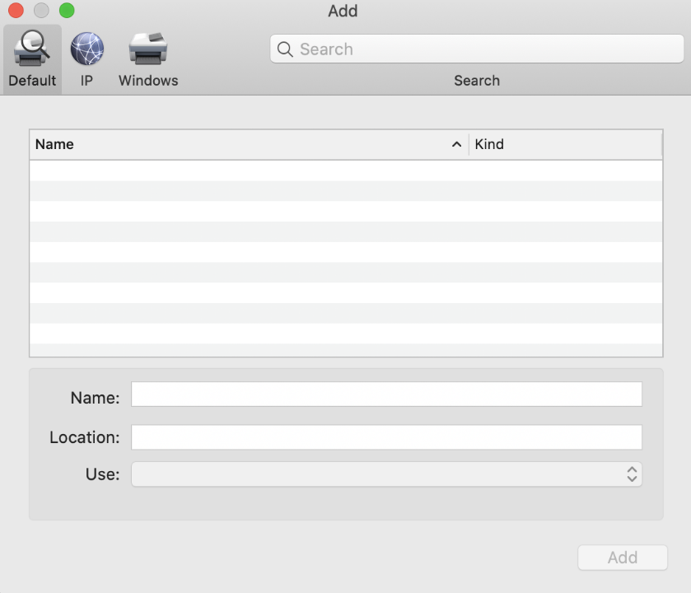

Step5: Long press the power button of the printer for 2 seconds, until the green light is on. Then plug in the USB cable.



The following page will show up, then click the red rectangle consequentially.

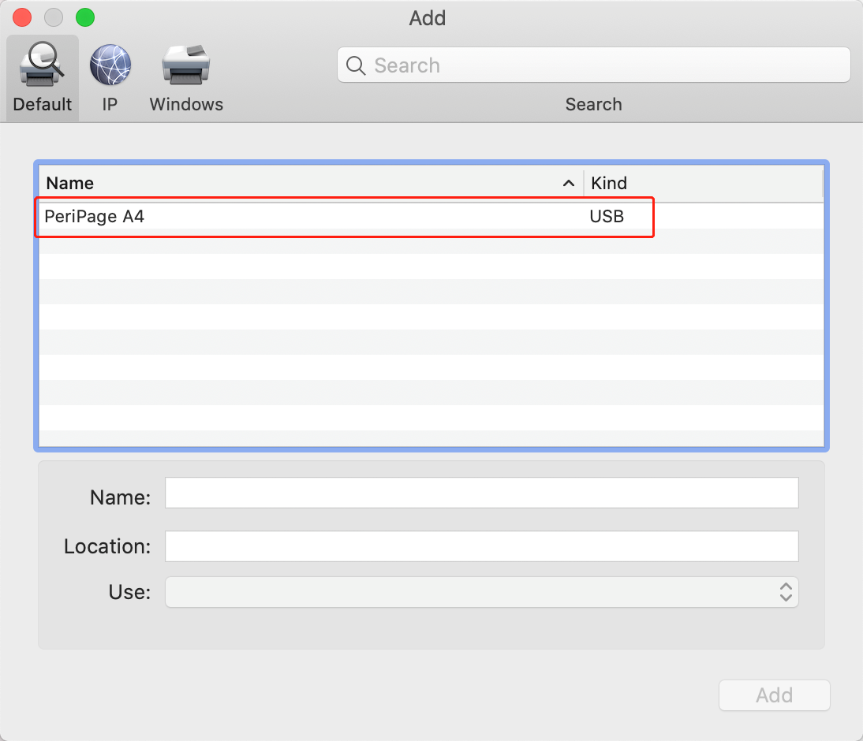

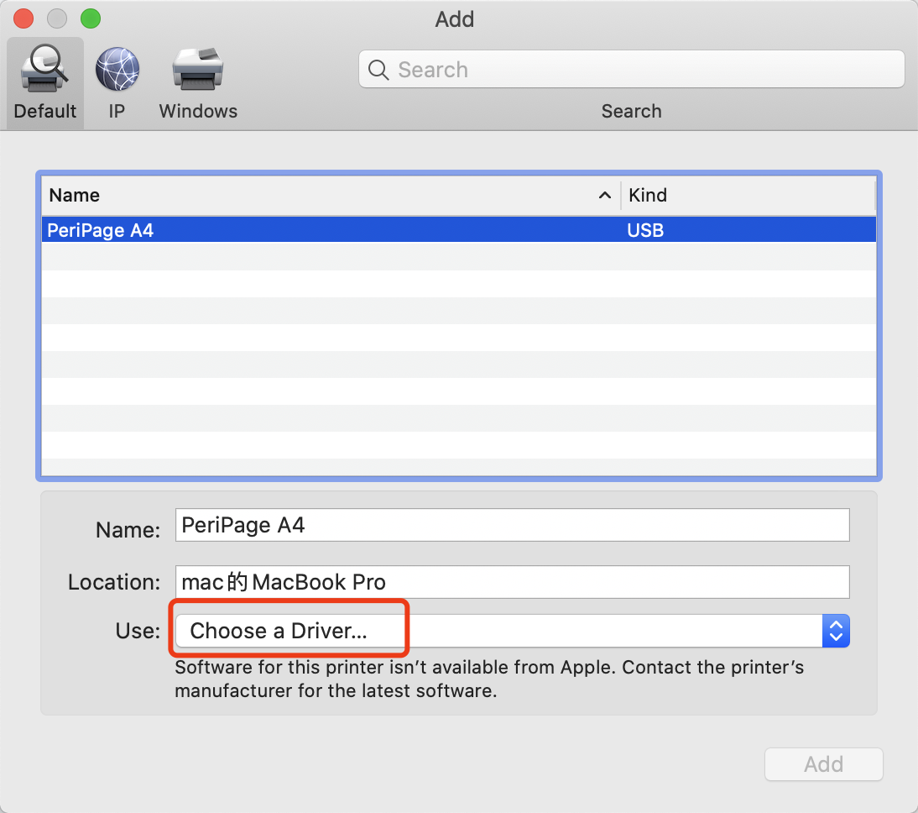

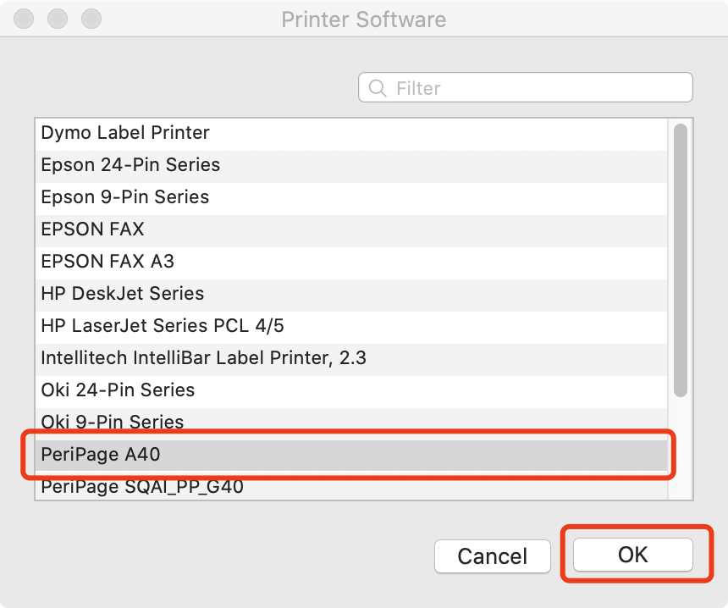

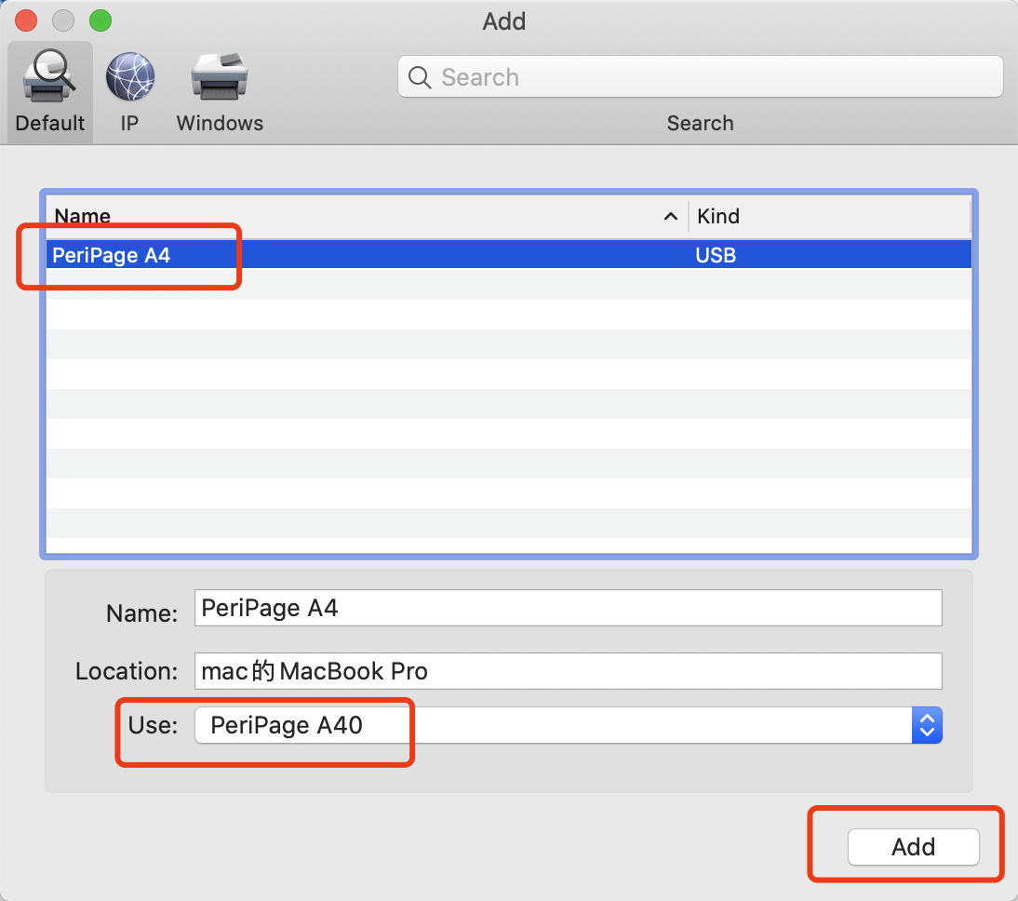

Step5: Open the file to be printed. Such as a Microsoft Word.

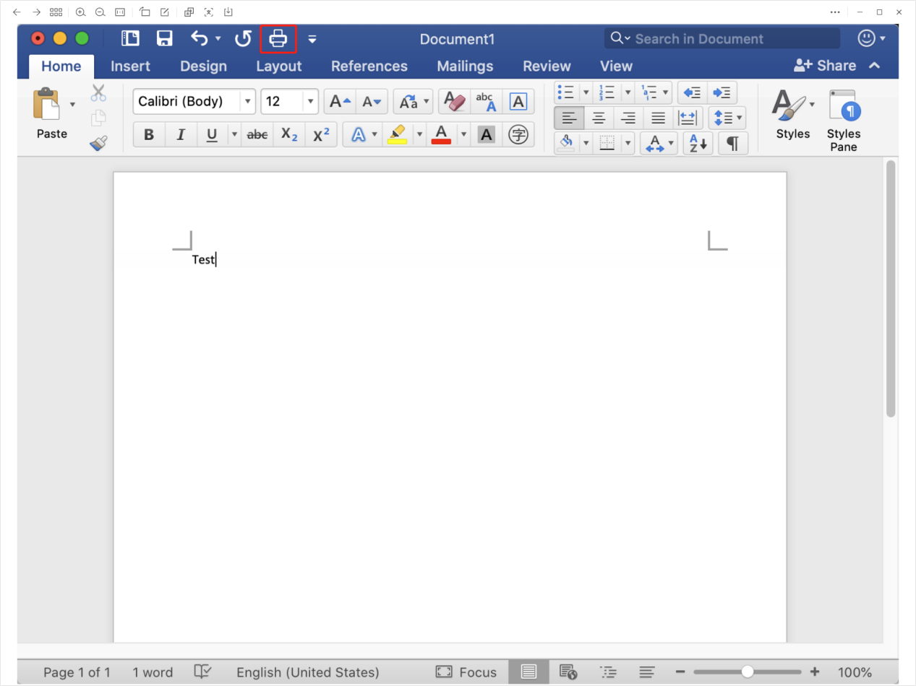

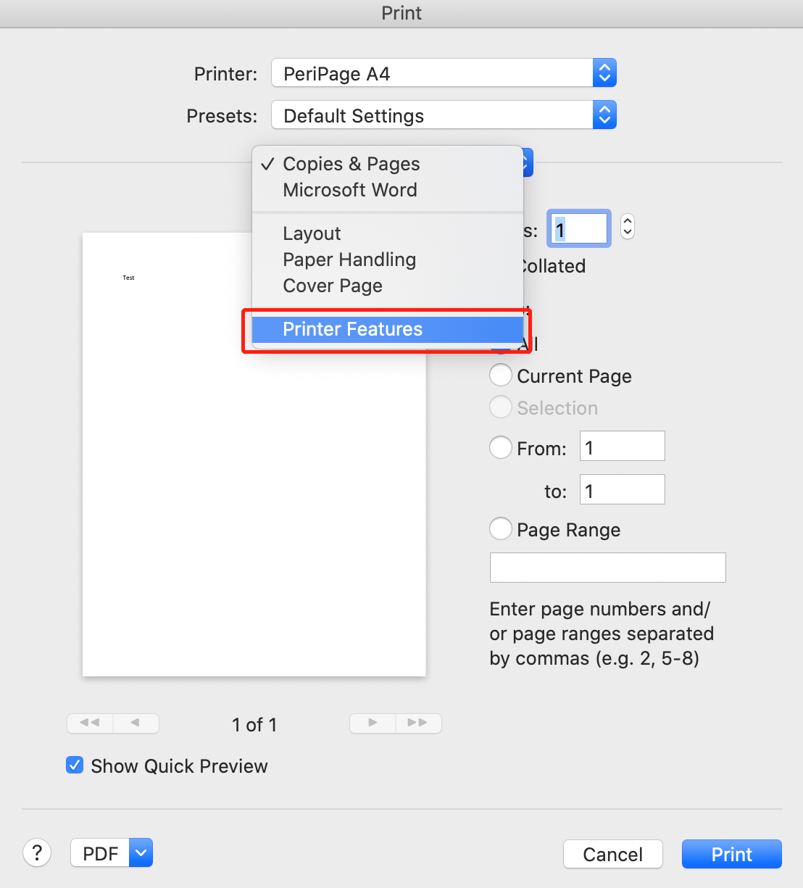

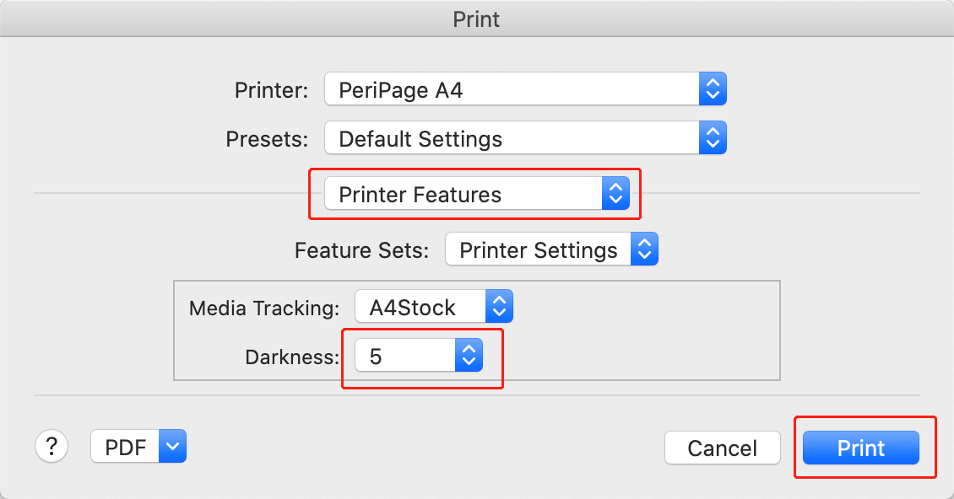

3.How to install APP in iPhone and android? How to print email in iPhone and android?

3.1 How to install APP and connect the printer in iPhone and android phone by Bluetooth?

Step1: Search “Peripage” in apple store or google play and install it.

Step2: Long press the power button of the printer for 2 seconds, until the light is green. If the light is not green, it will not connect the phone.

Step3: Turn the phone Bluetooth on.

Step4: Run the Peripage app. And connect the printer as the following picture:

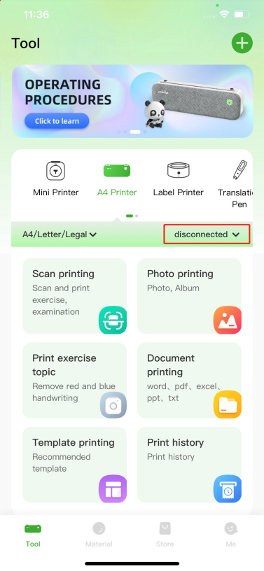 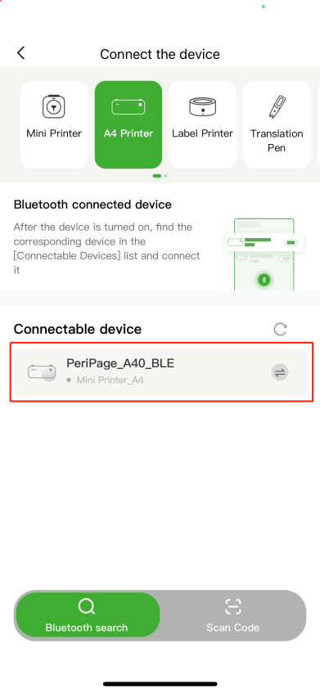 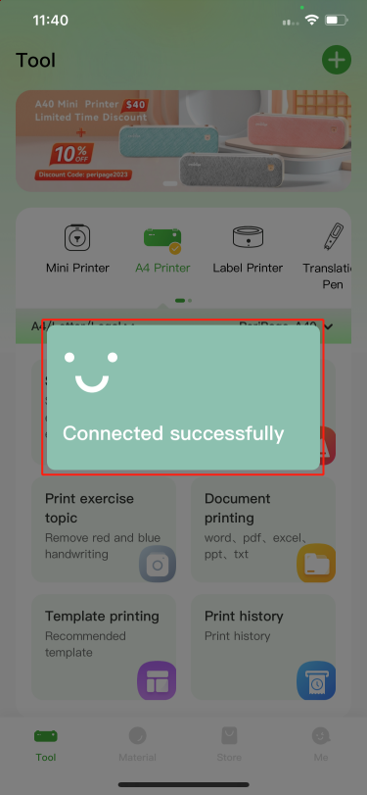

3.2 How to print email in iPhone?

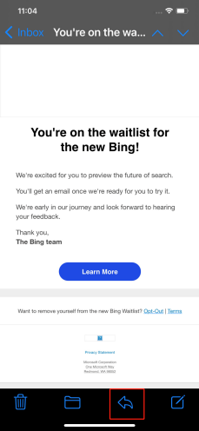 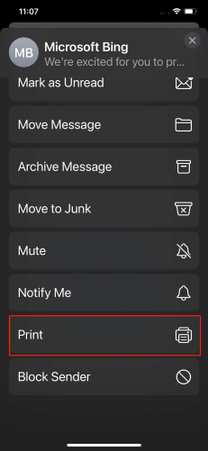 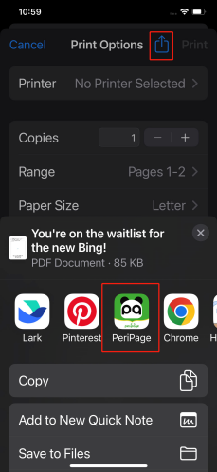 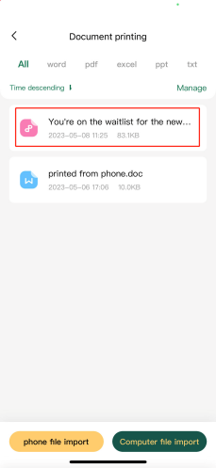 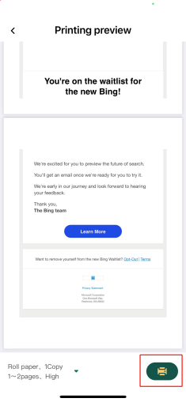

3.3 How to print gmail in android phone?

Save the email as PDF and run Peripage to print the PDF file.

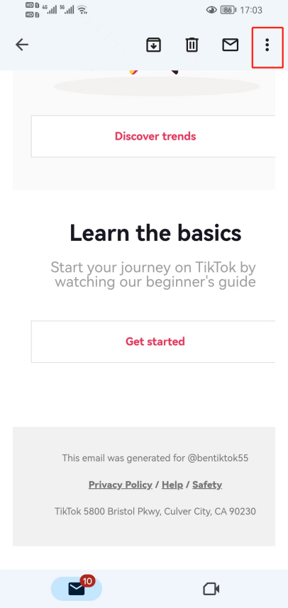 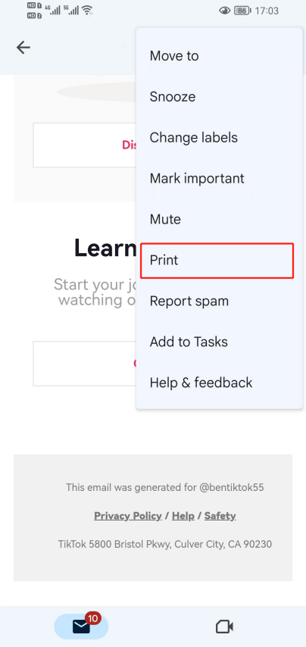 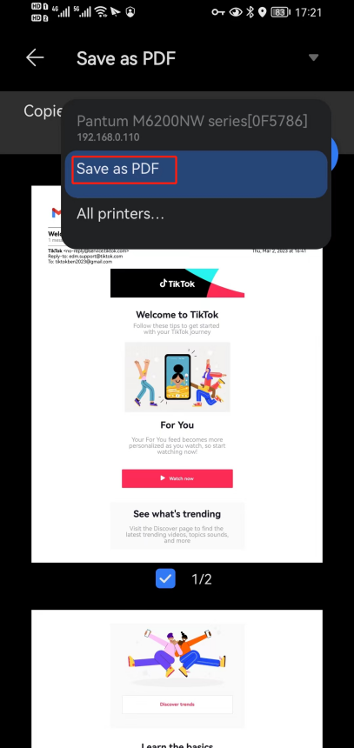

4.How to print 4”x 6” shipping label in Windows?

Step1: After installing the printer driver, install the 4”x6” shipping label by moving the two stoppers to the 4” locations successfully. 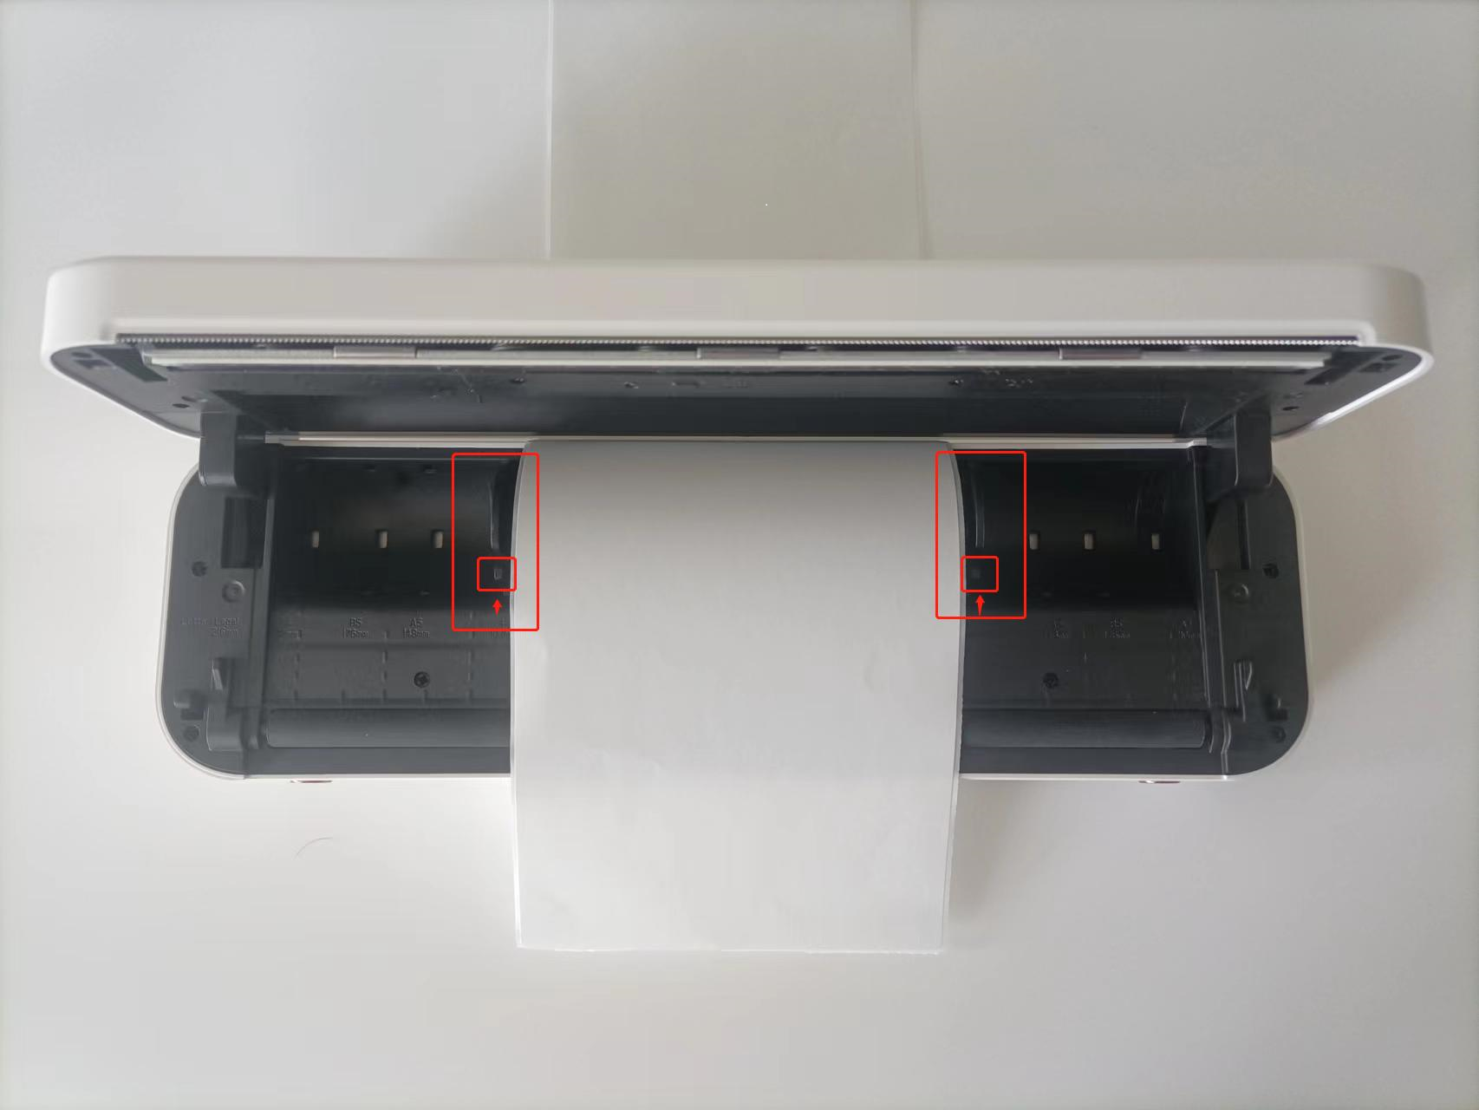

Step2: Go to windows settings.

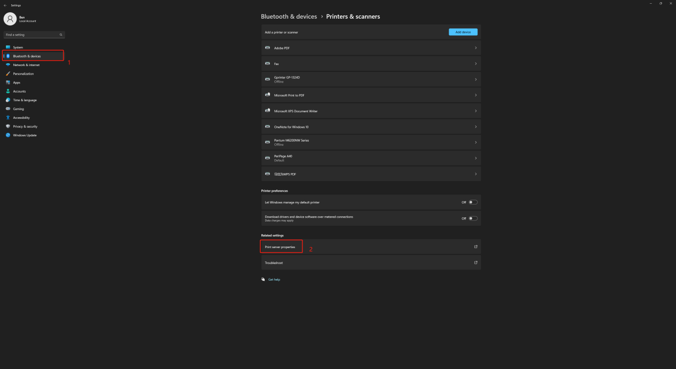

Step3: Create a 4*6inch form.

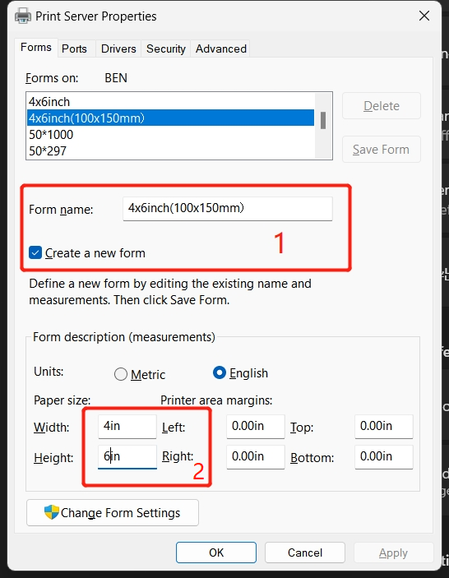

Step4: Right click the 4”x6” shipping PDF file and open with edge browser.

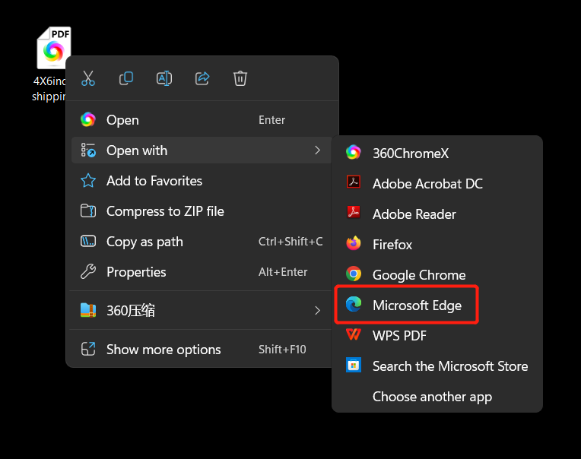

Step5:

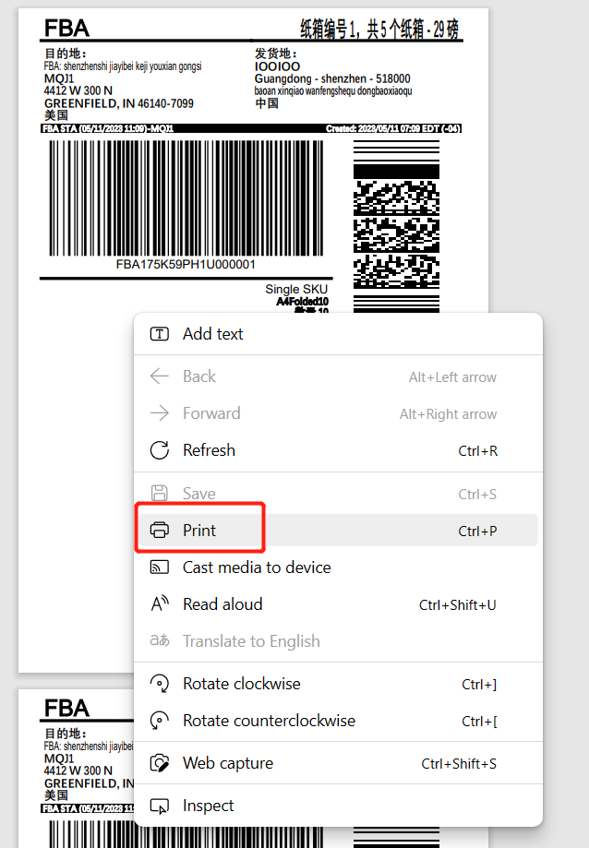

Step6:

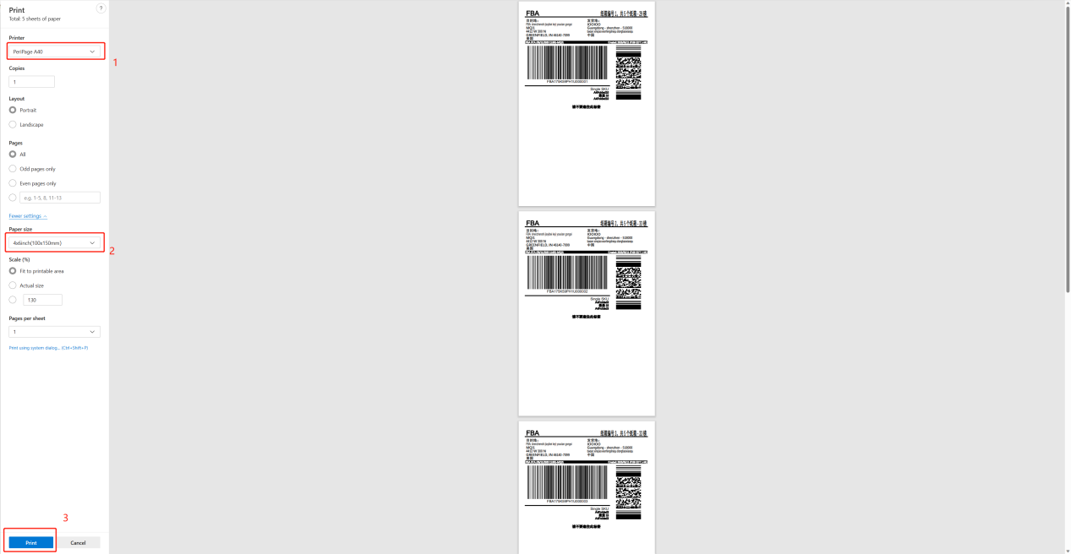

Step7: The print will come out.

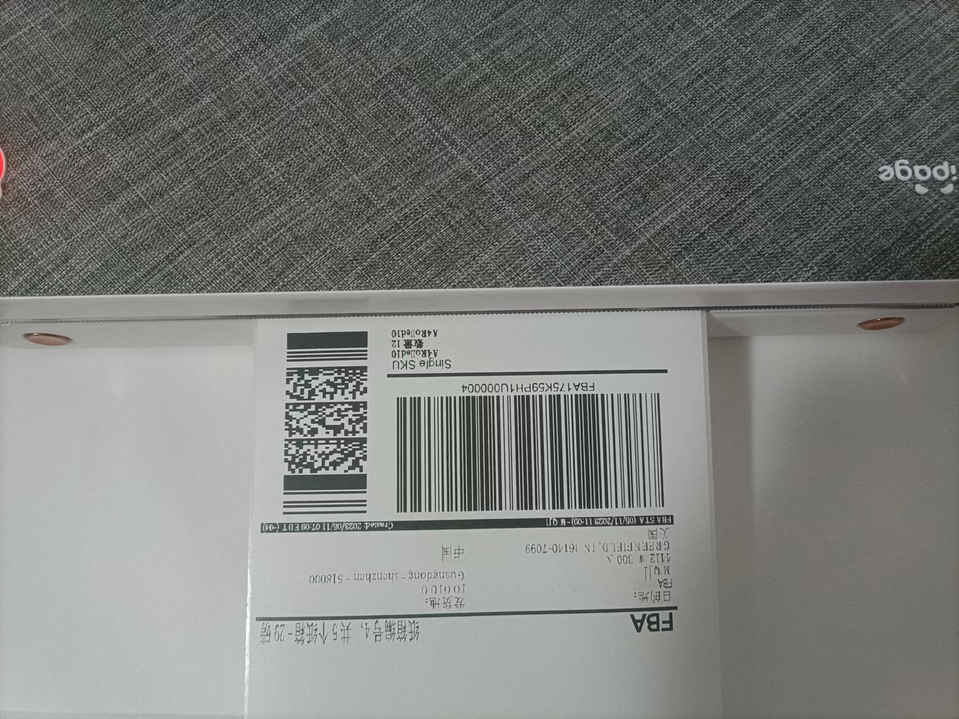

5. How to print 4”x6” shipping label in Mac PC?

Step1: After installing the printer driver, install the 4”x6” shipping label by moving the two stoppers to the 4” locations successfully.



Step2: Open the 4”x6” shipping label file with Sarafi.

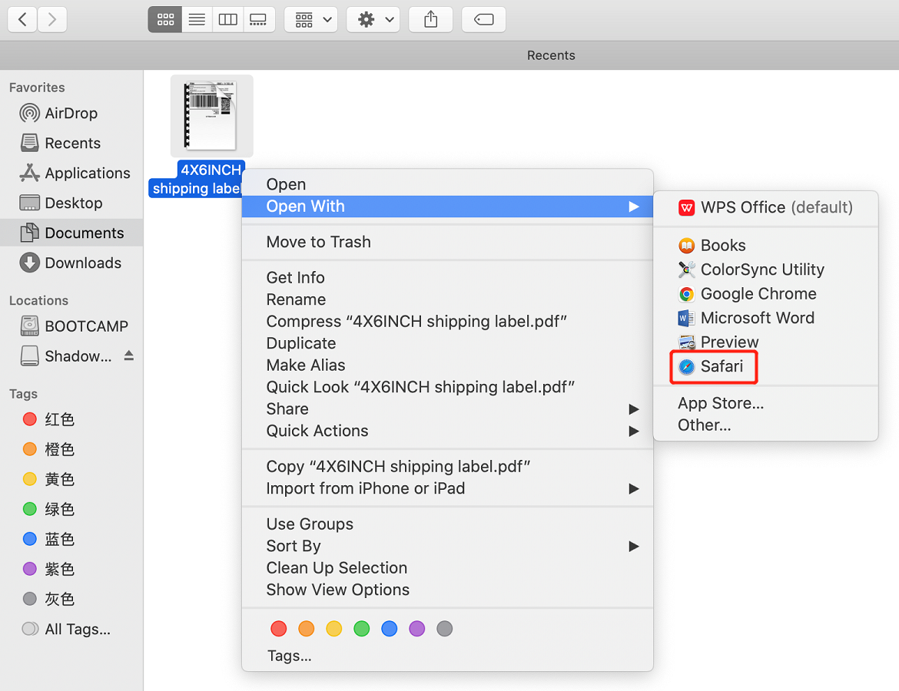

Step3: Click the print menu.

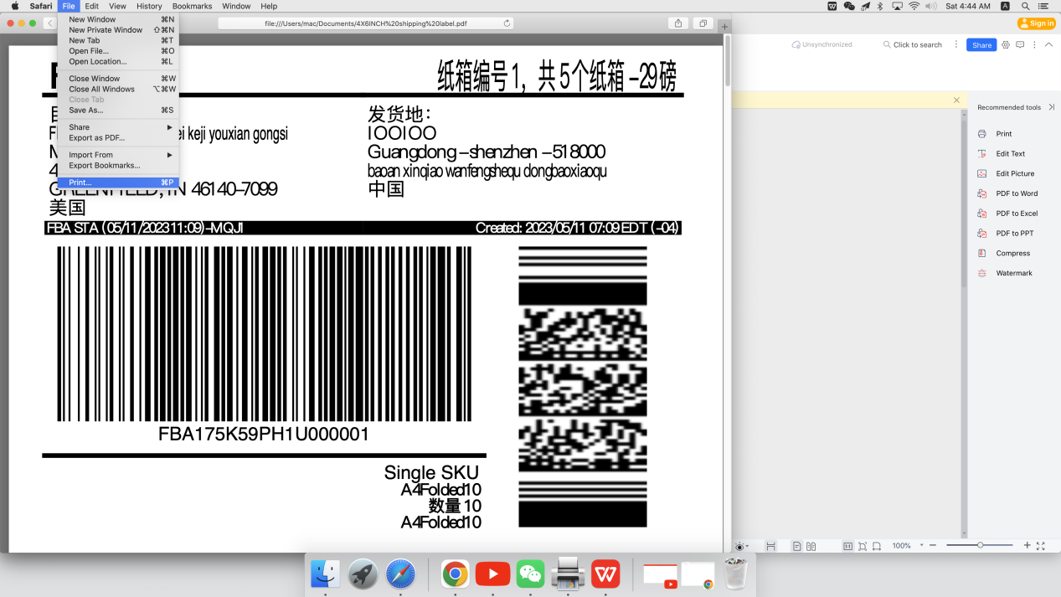

Step4:

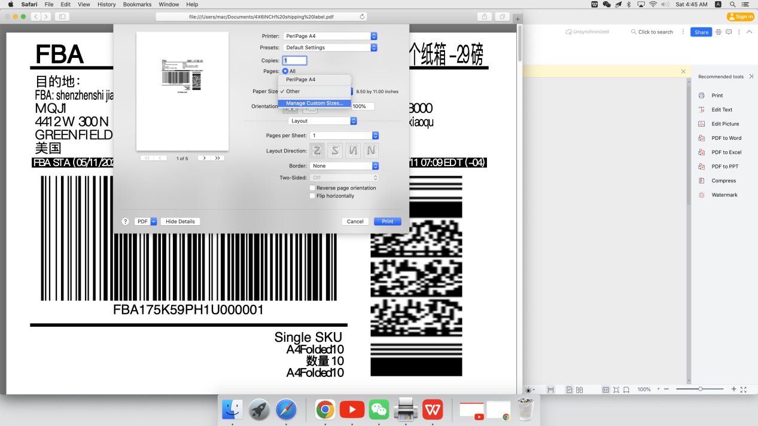

Step5:

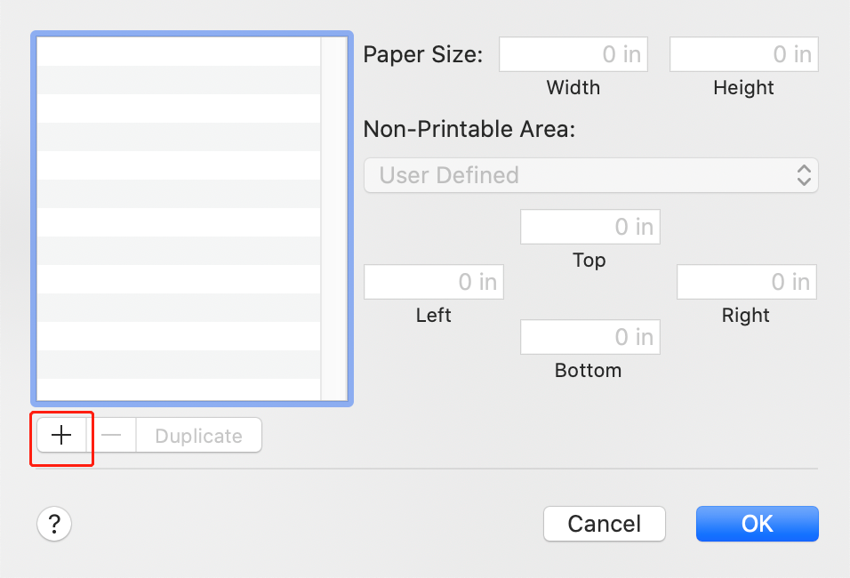

Step6:

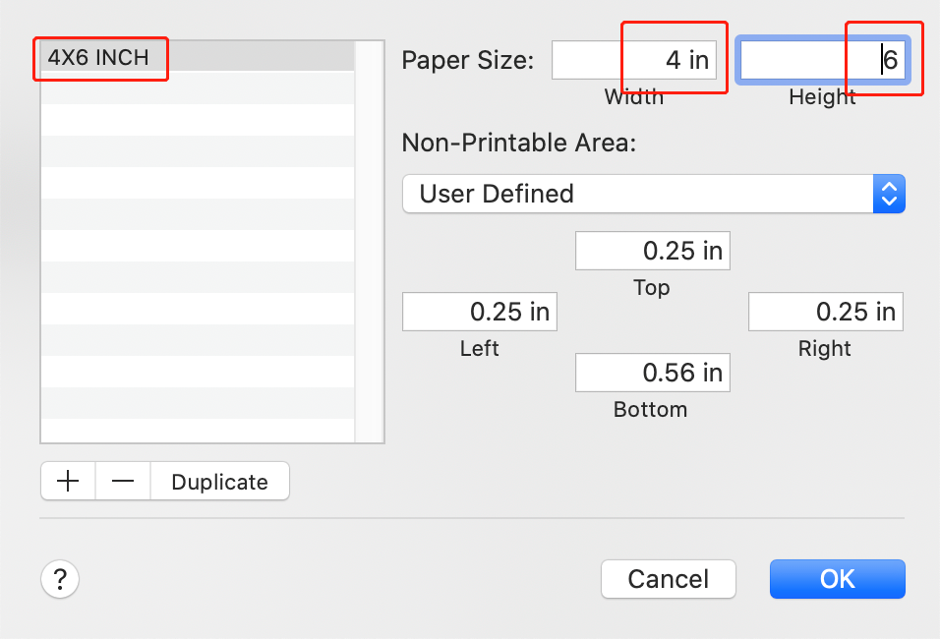

Step7:

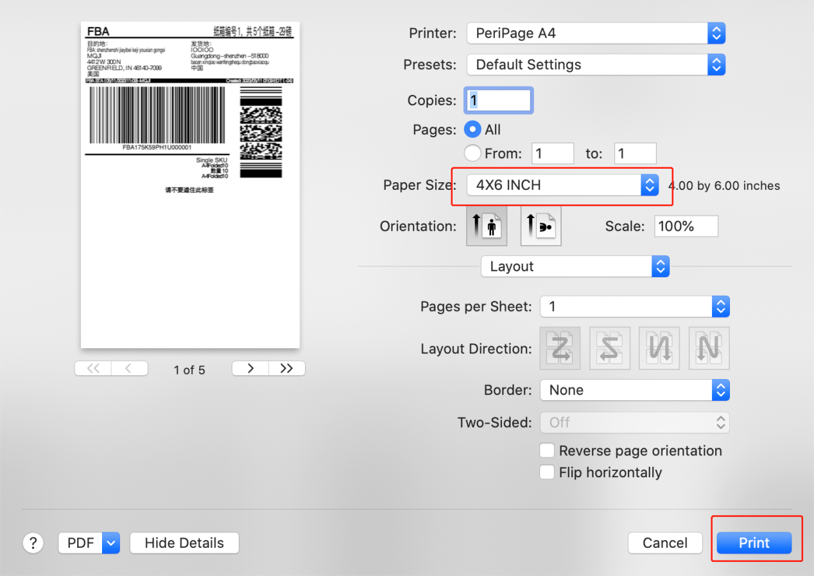

Step8: The print will come out as the following.



1. How to connect Windows PC with printer by Bluetooth?

Step1: Turn on the printer until the green LED is on and turn the Bluetooth of the PC to be ON.

Step2: Run the driver and select Bluetooth as the following and click Next:

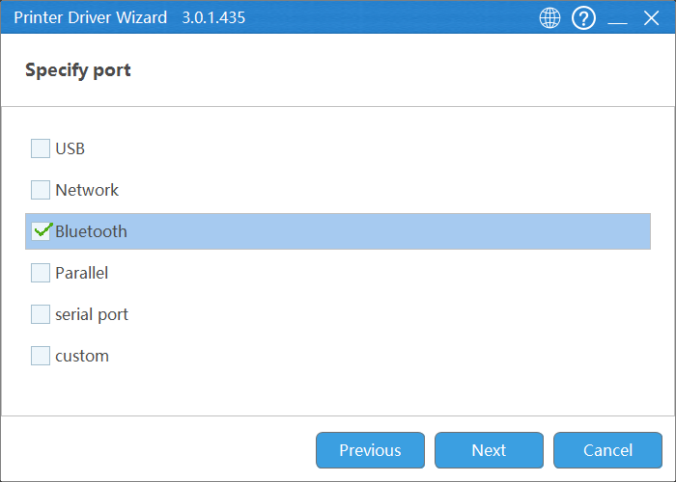

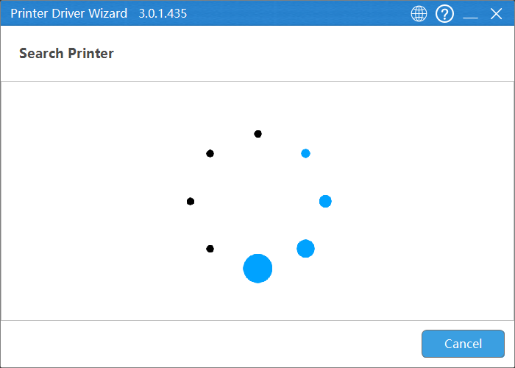

Then windows will pop up the following windows:

Click this window:

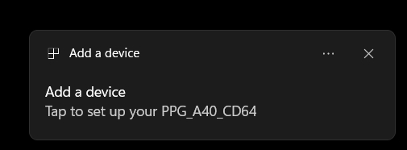

Click Allow:

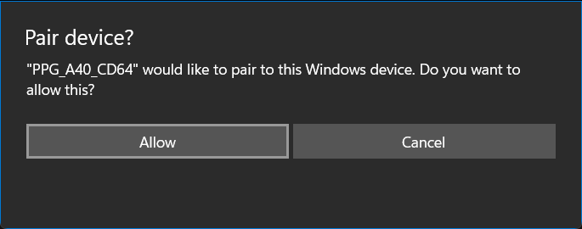

Click Close:

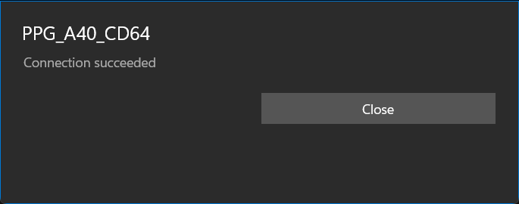

Step3: Select the following item, and click next:

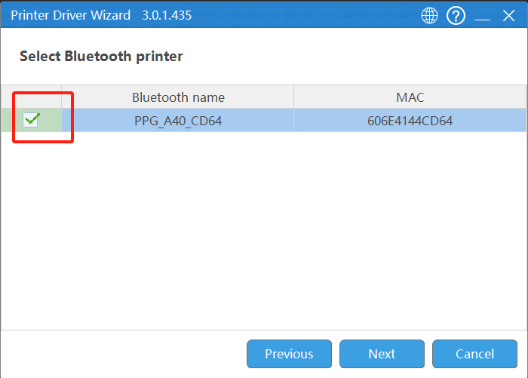

Step4: When the printer is on, double click the printer power button to print out the hardware version, and find out the driver is one of PPG A40 SD (For 200 DPI version), PPG A40 HD(For 300 DPI), Peripage A40 or Peripage A40+(For 300 DPI version):

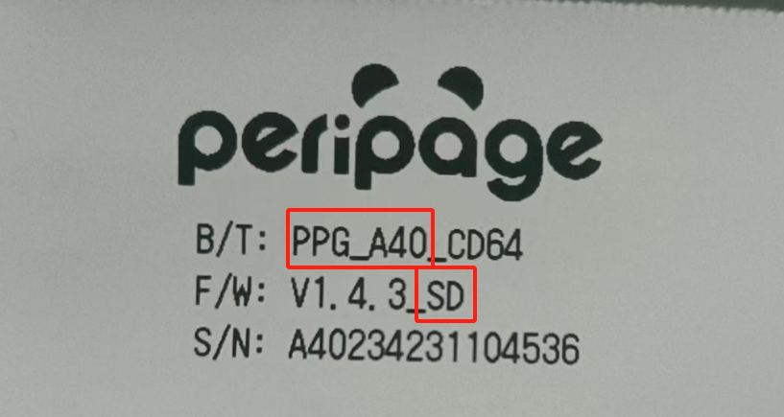

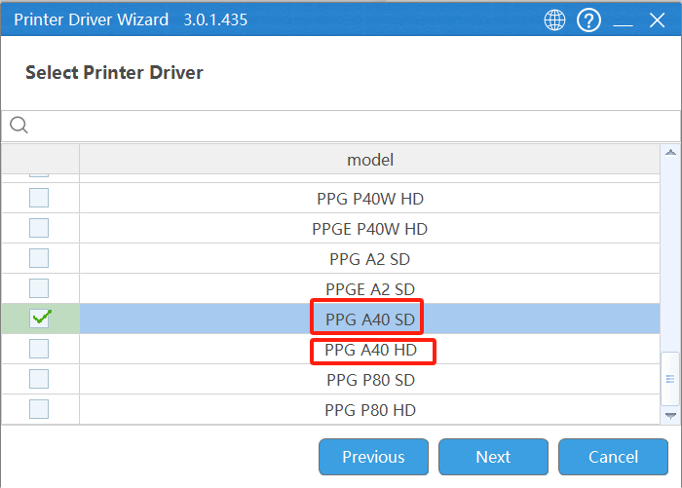

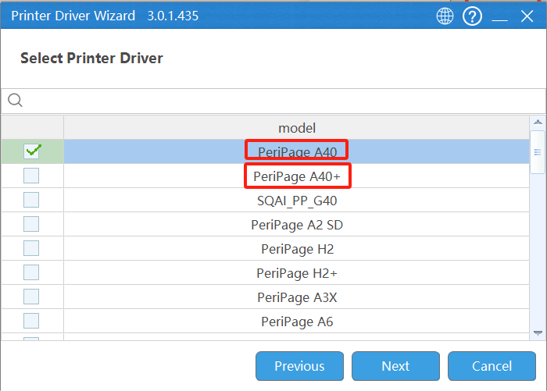

Step5: Deselect the item ”Use this printer as default”, then click next.

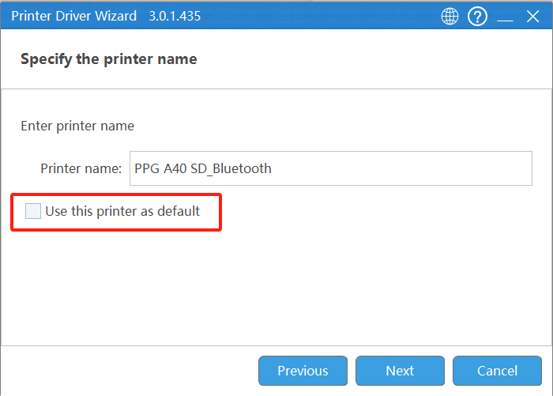

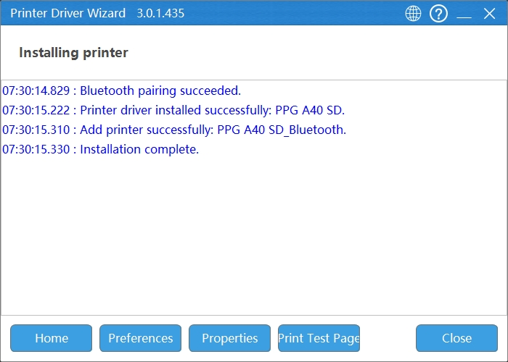

Step6: Click “Print Test Page”, it will print out a test page.